1. Create a django project named library

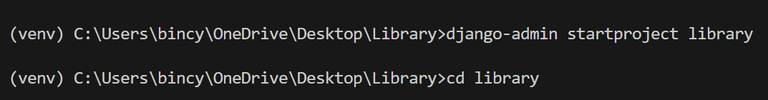

1. Inside the project create and app named book

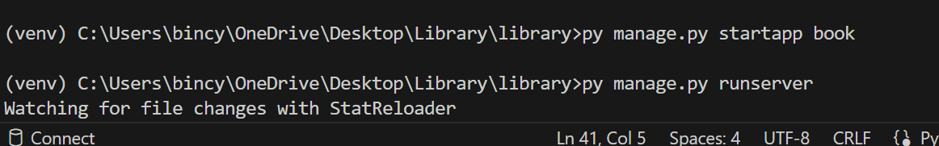

1. create 2 models in the app for storing data of books and authors -- authors[first_name, last_name, email, books_count, average_rating] -- books[name, price, average_rating, count, author(foreign key)]

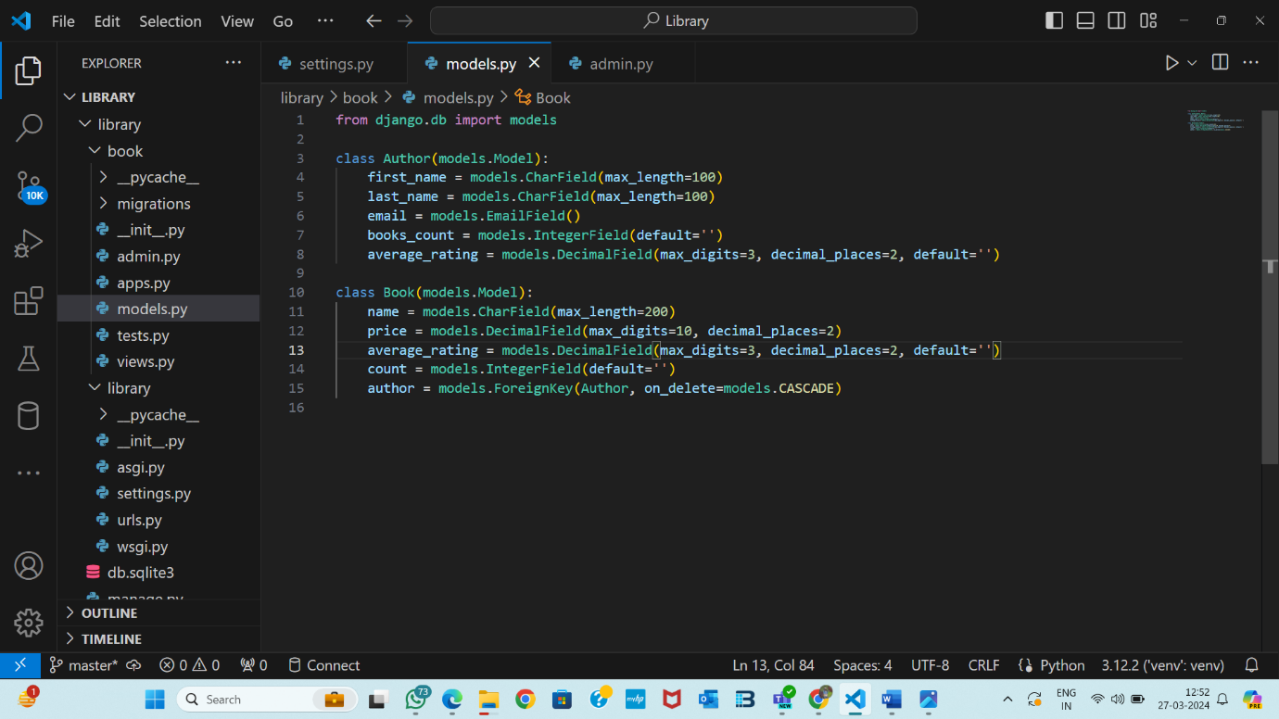

1. install django-extensions package and use shell_plus to run queries

-- create 5 authors

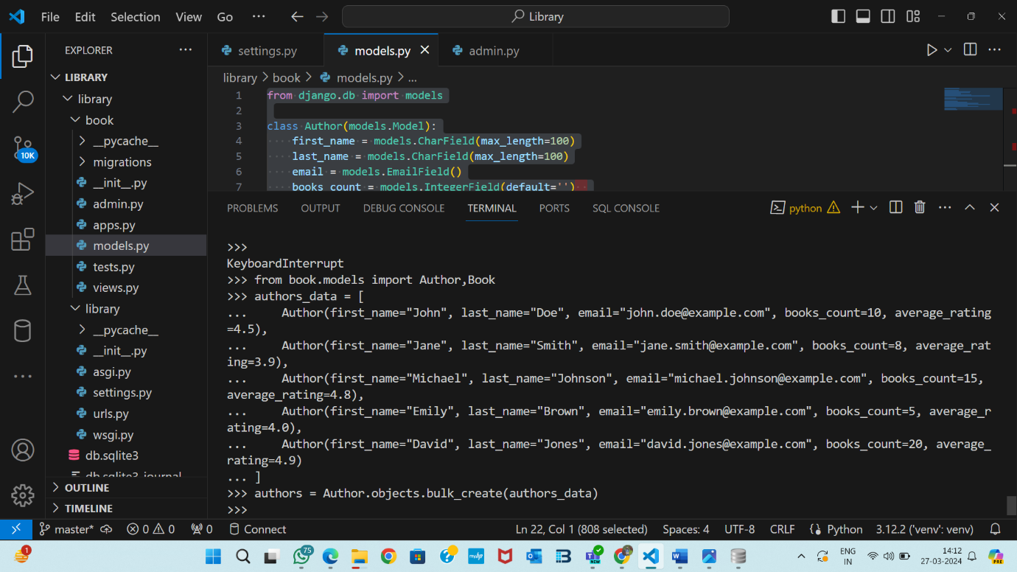

-- create 10 book

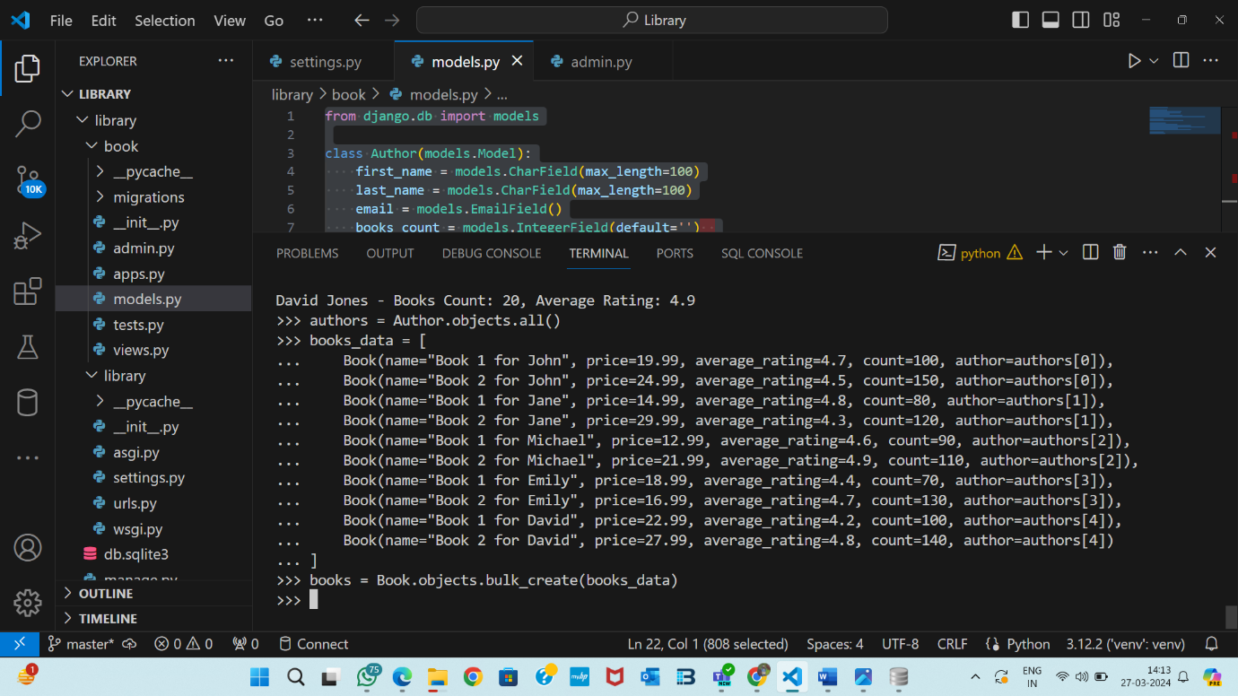

-- show all the objects in books and authors model

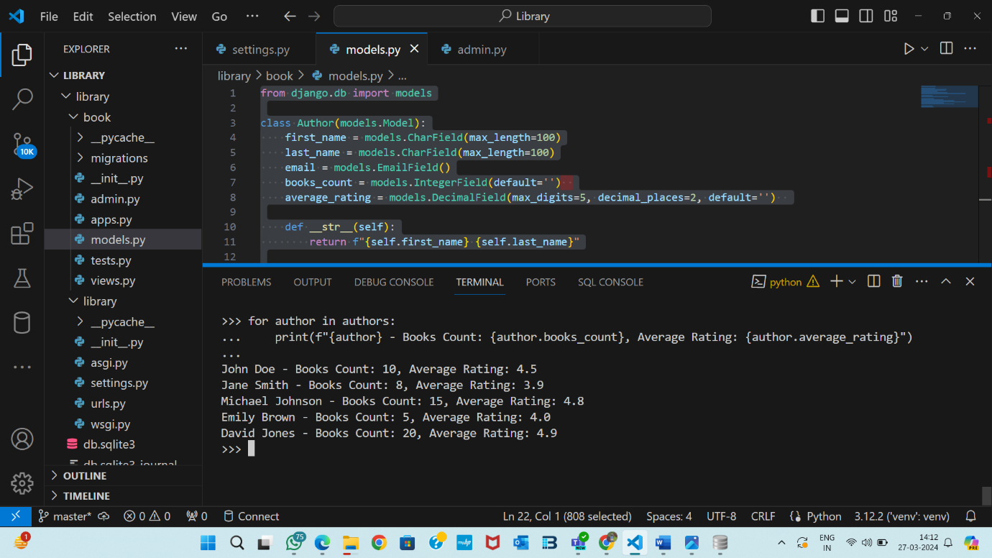

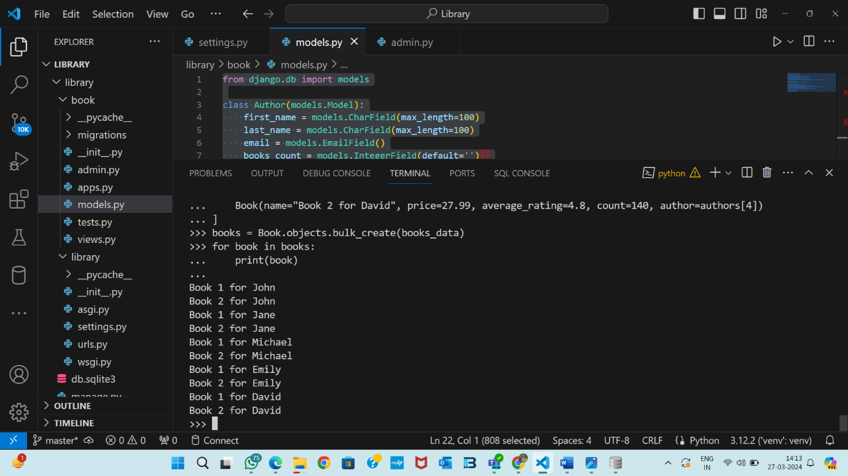

-- filter and show some authors using first_name field

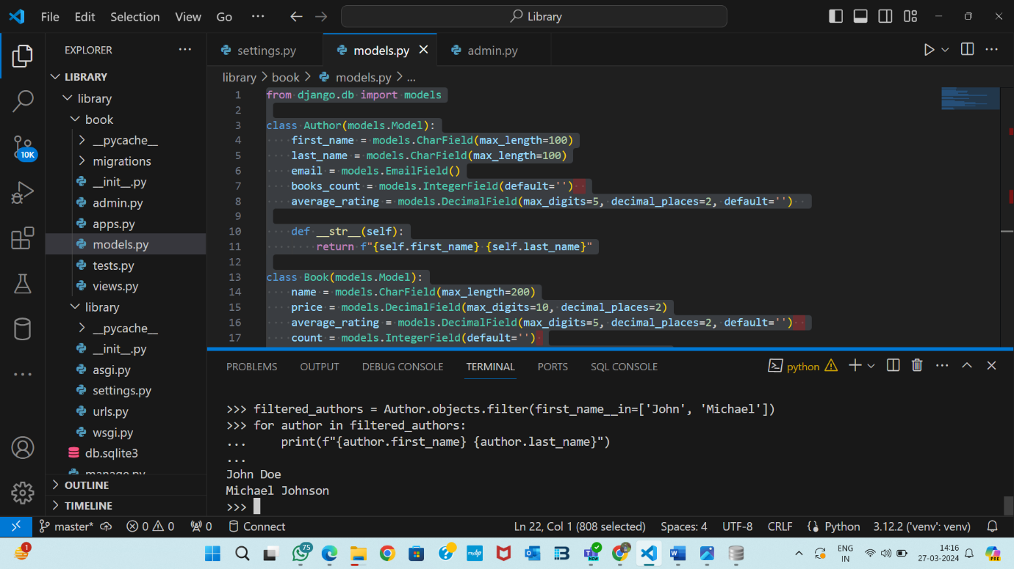

-- filter and show some authors that does not have a last_name

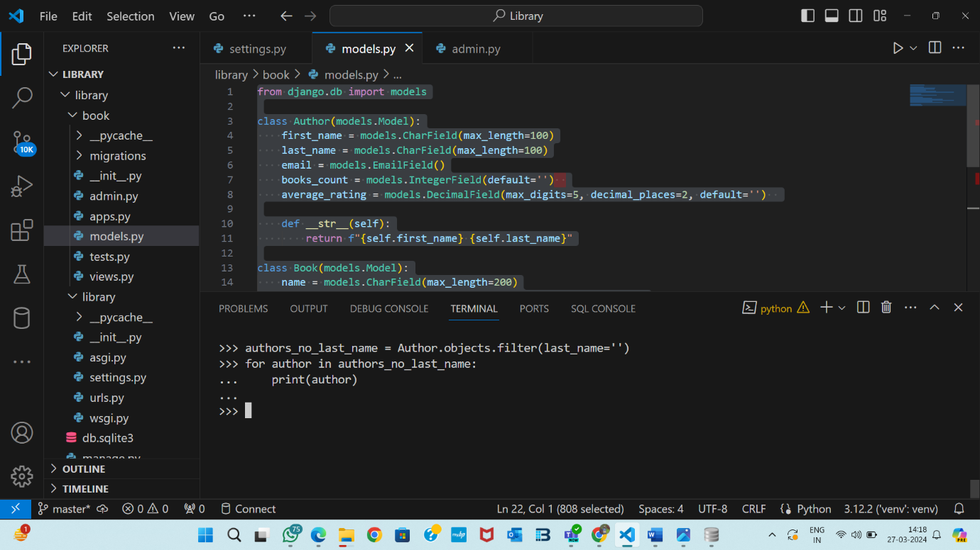

-- filter and show some authors that have books count greater than 10

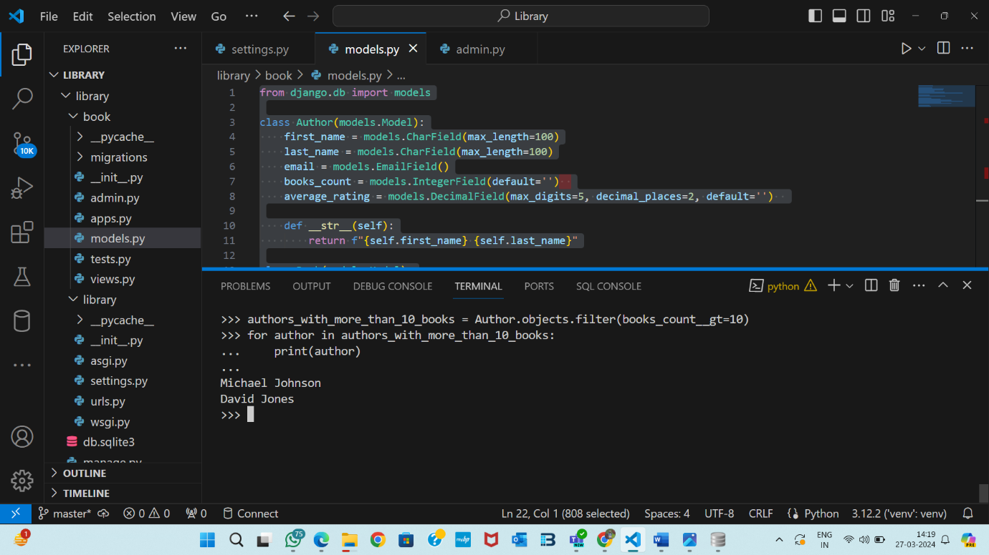

-- filter and show some authors that have an average rating less than or equal to 3

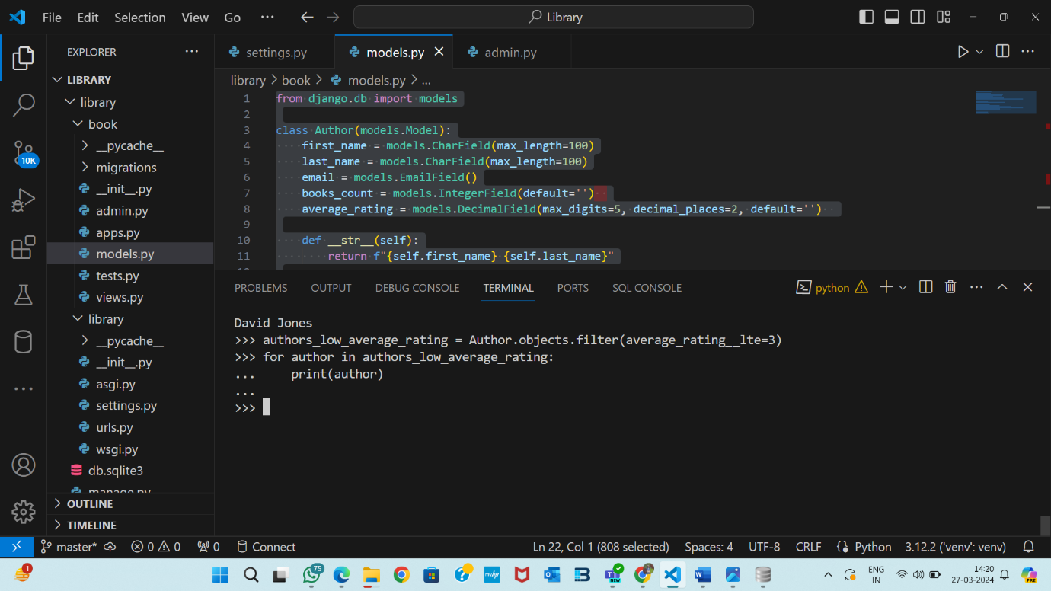

-- filter and show some books that have price less than or equal to 500

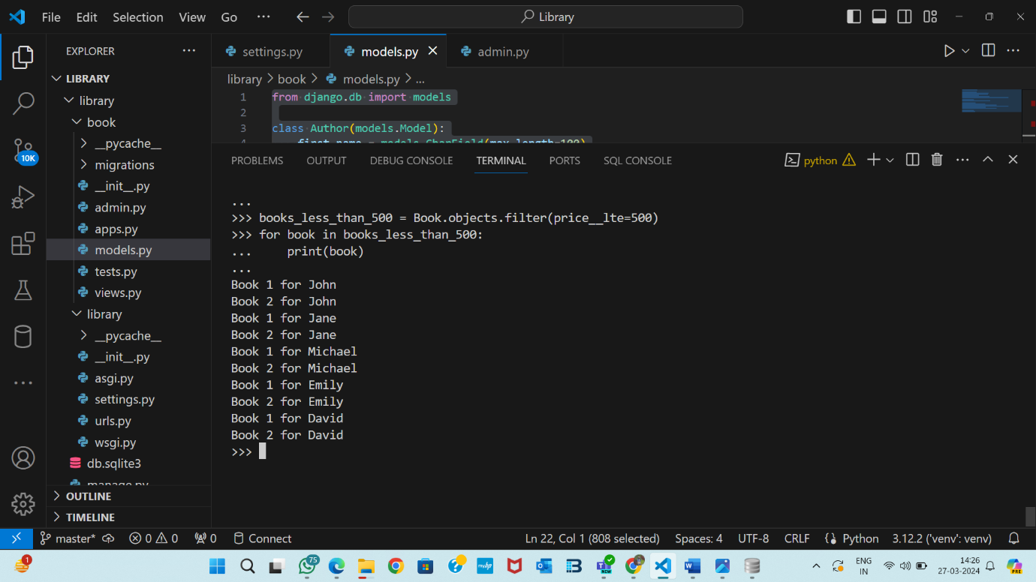

-- filter and show some books that have proce grater than or equal to 700

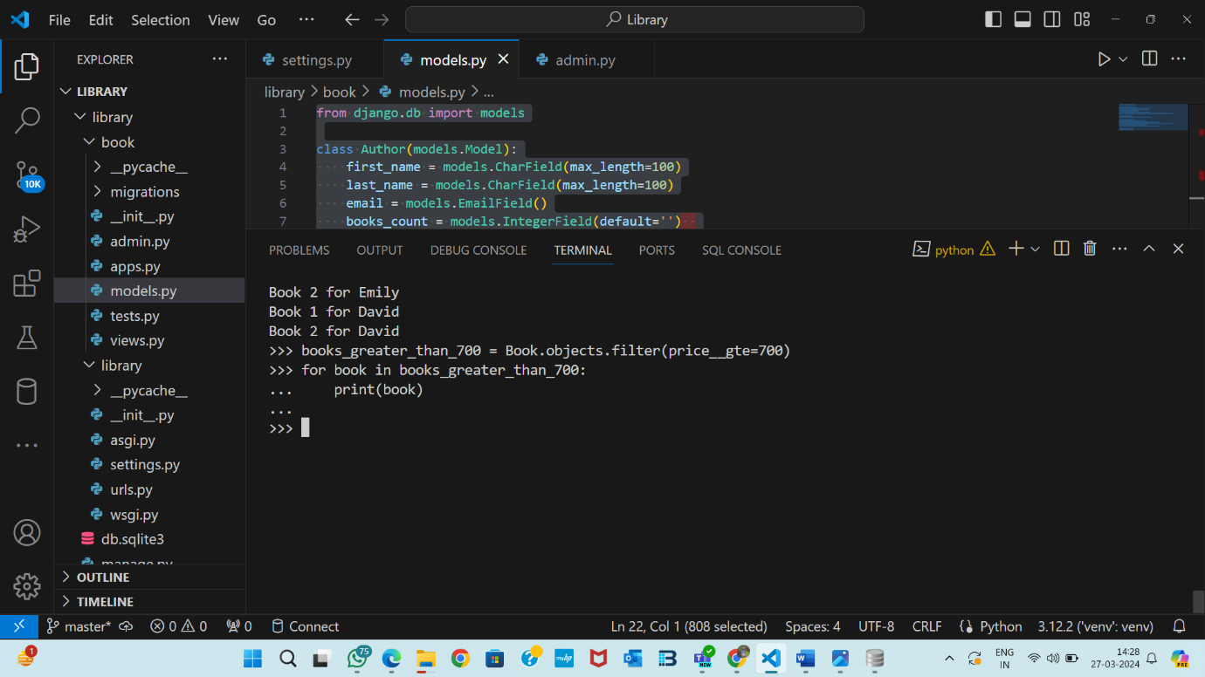

-- filter and show some books that has an average rating greater than 3

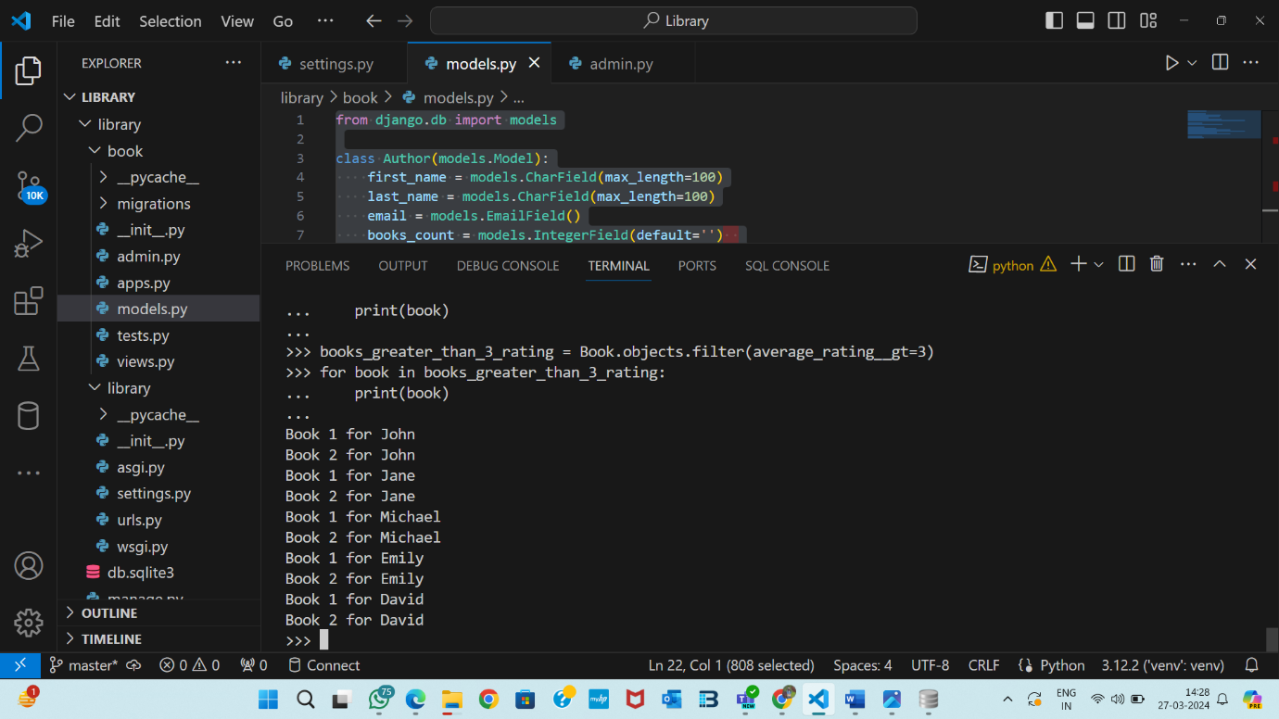

-- filter and show some books that has count greater than 100

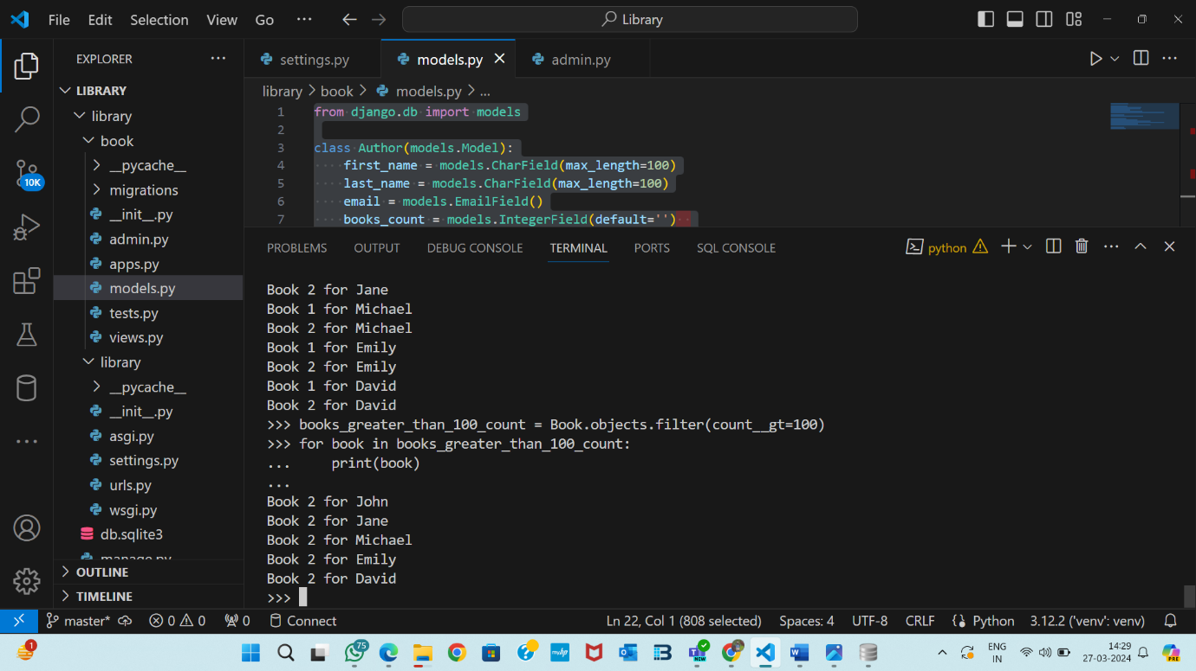

-- filter some books that has price greater than 500 and show the names of all one by one along with its price and author's first name

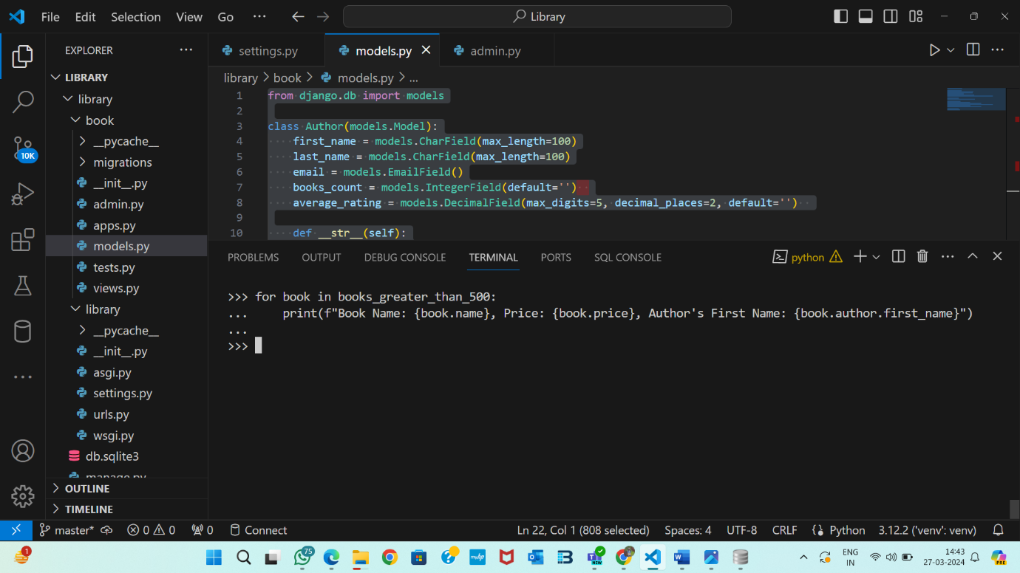

-- fetch the first book and show its name

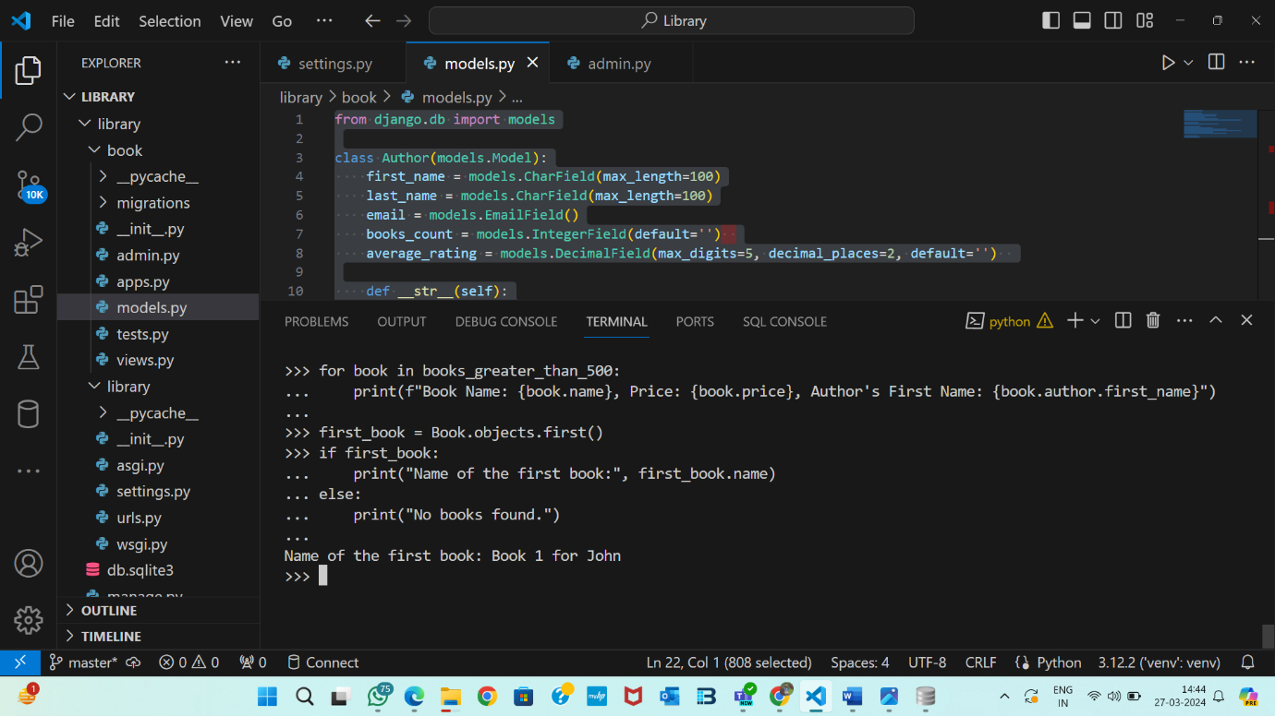

-- fetch the last book and show its authors full name

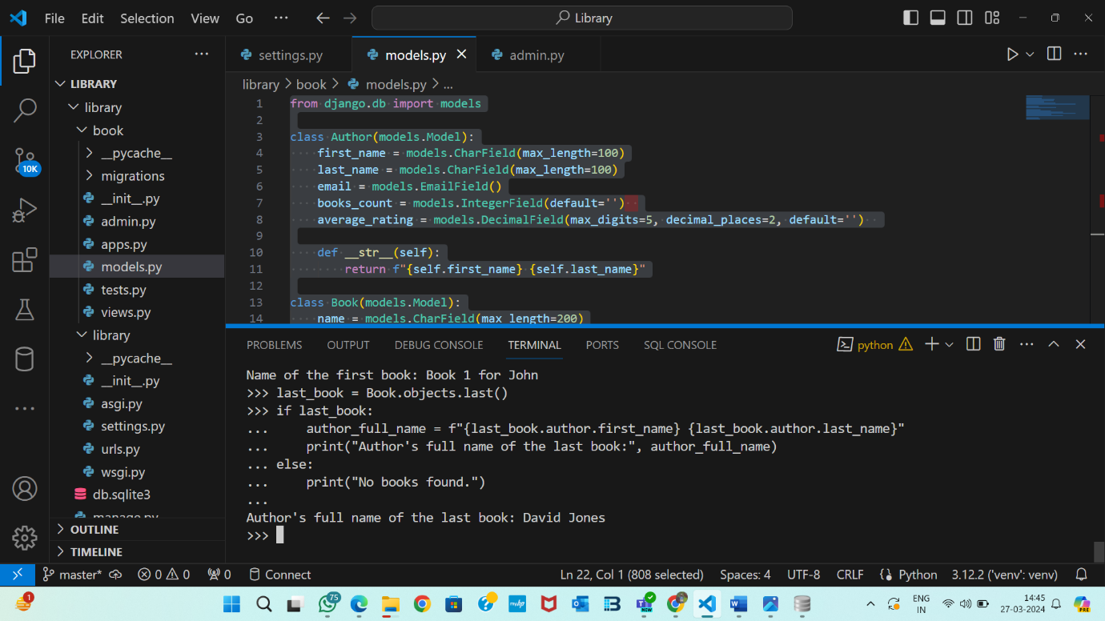

-- fetch a book using its id, show its name and author's full name

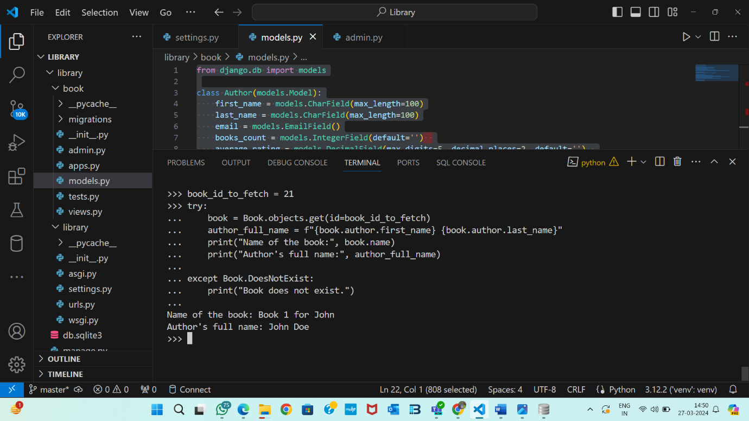

-- show the total count of books and authors

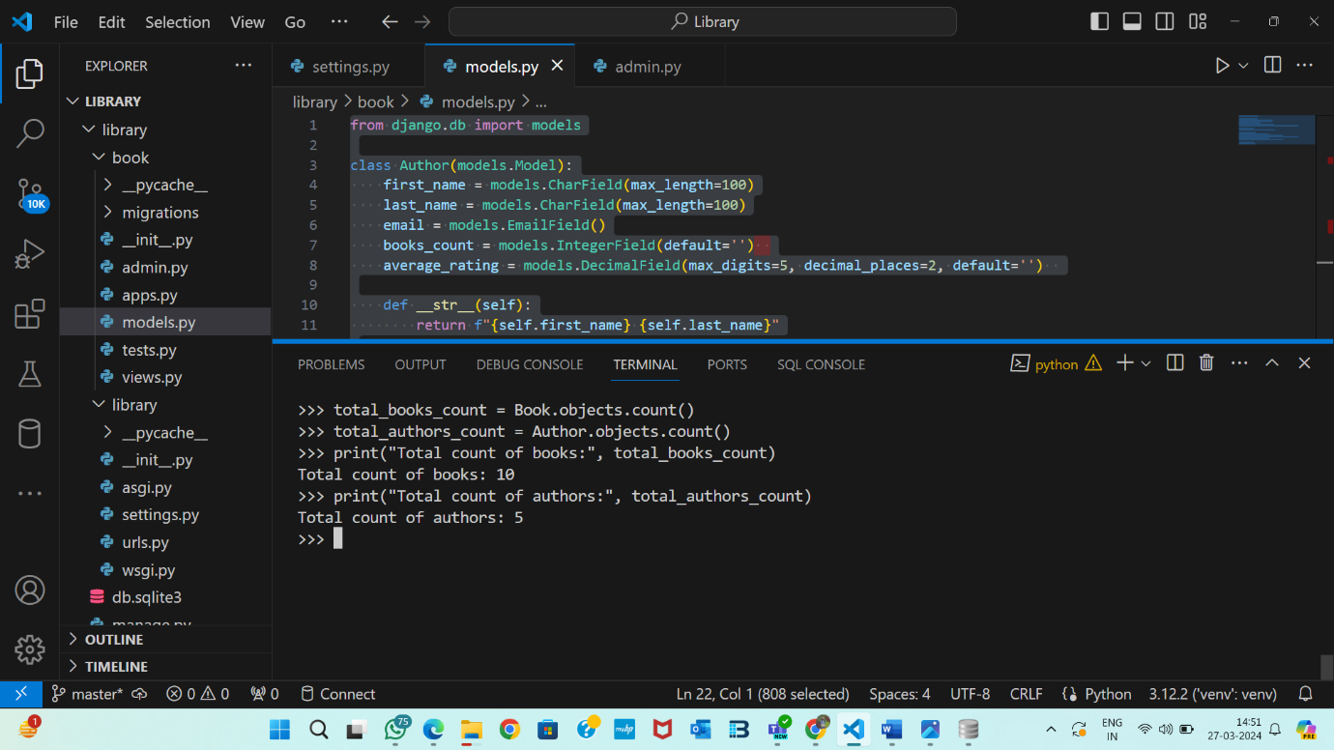

-- fetch a book by its id and update the author and save

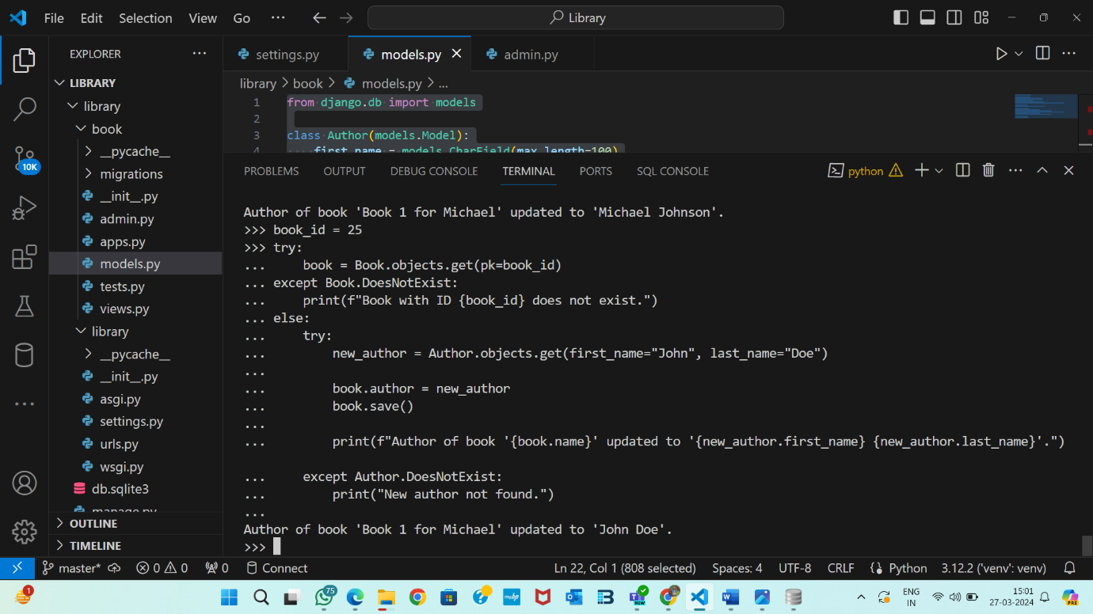

-- show the total count of authors

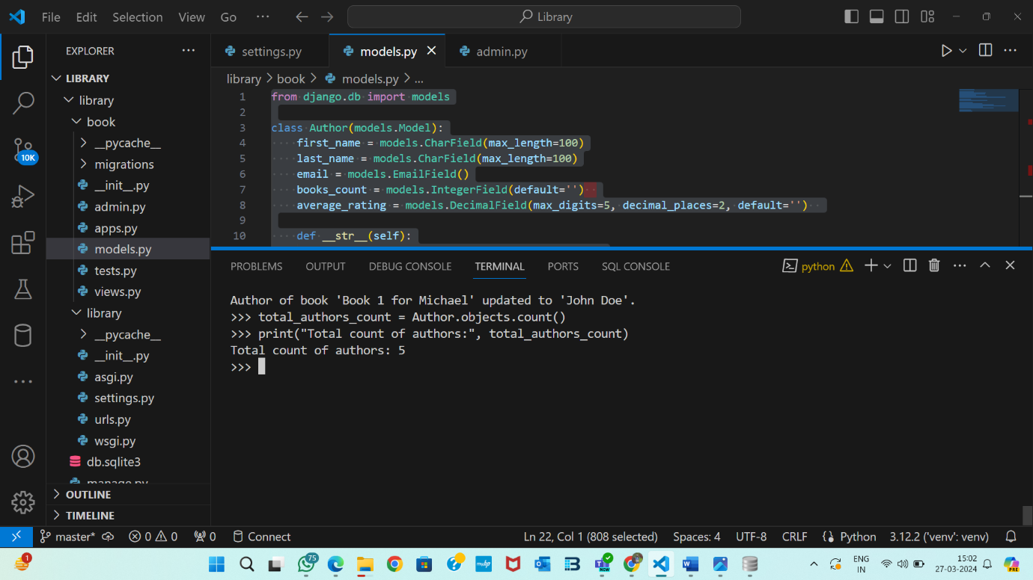

-- show the count of authors that has an average rating greater than or equal to 3

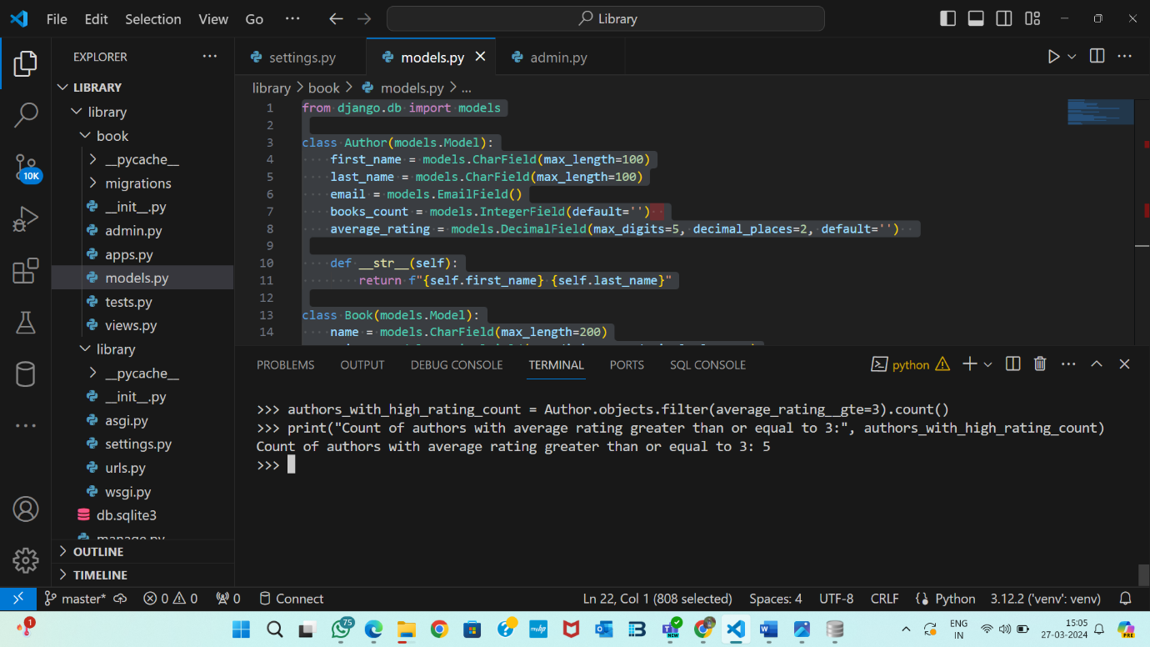

-- check whether an author exists in the table using email field

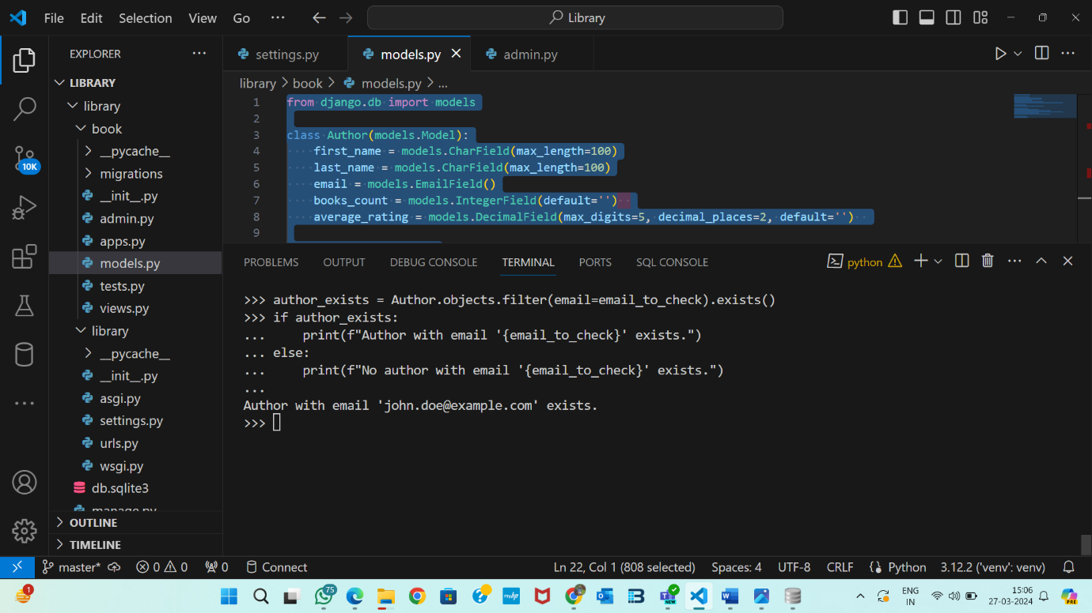

-- check whether a book exists in the table with its name

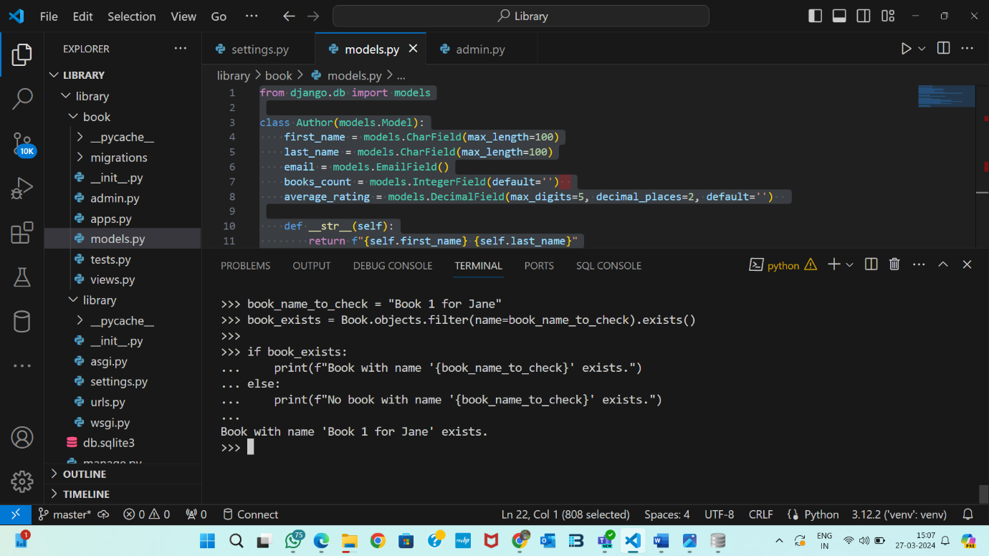

-- show all the books in the order of its name

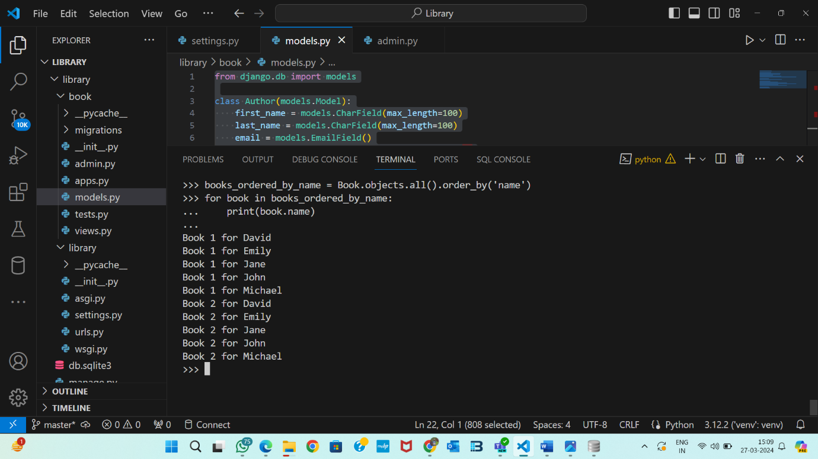

-- delete 2 books from the table after fetching it with name

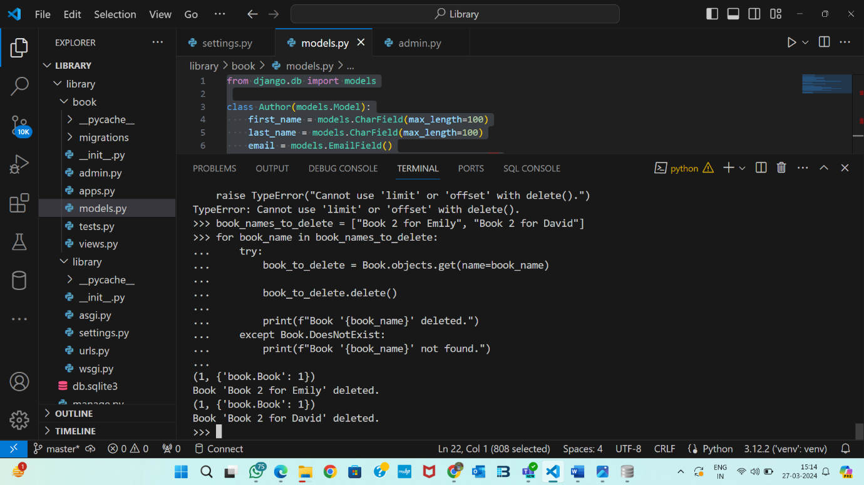

-- update the books count value after fetching a book using its name

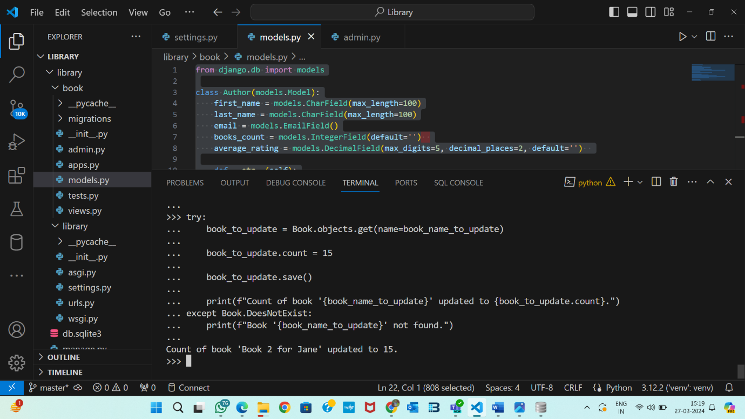

-- filter and show the name of books that has books count less than or equal to 20

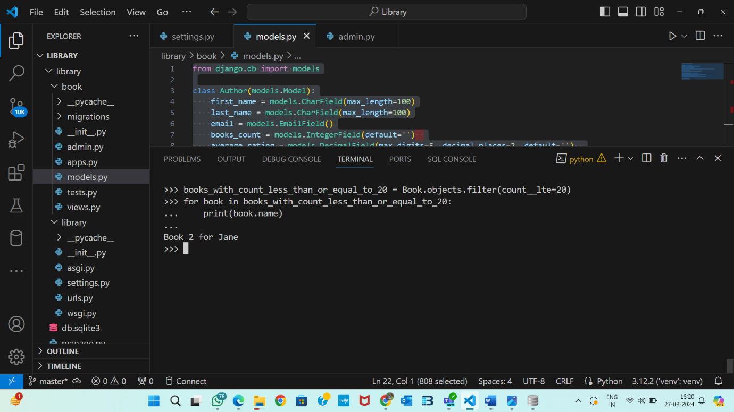

-- show all the authors that has first name starting with "a"

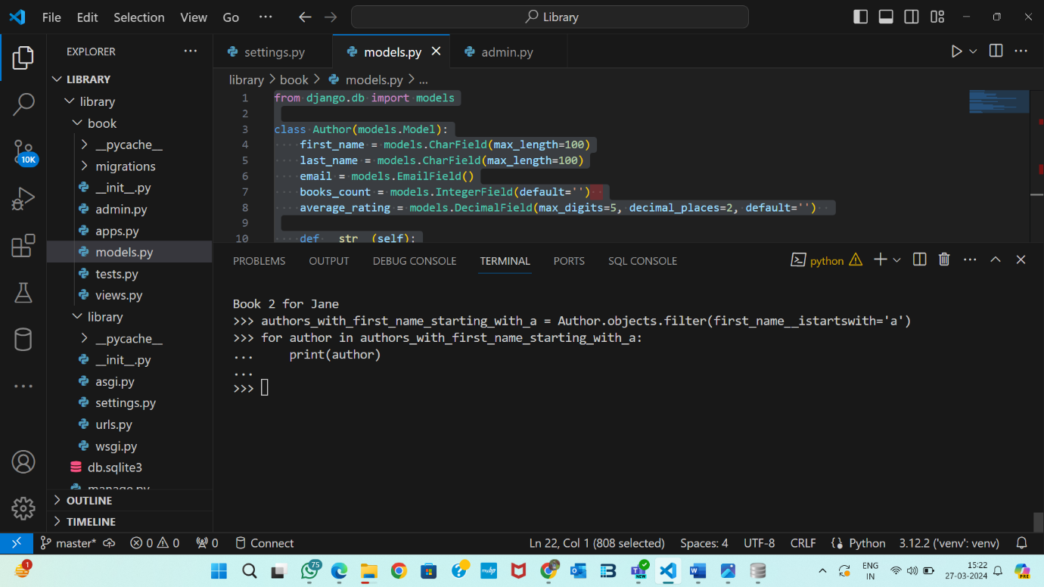

-- show all the authors that contains "d" in the first name

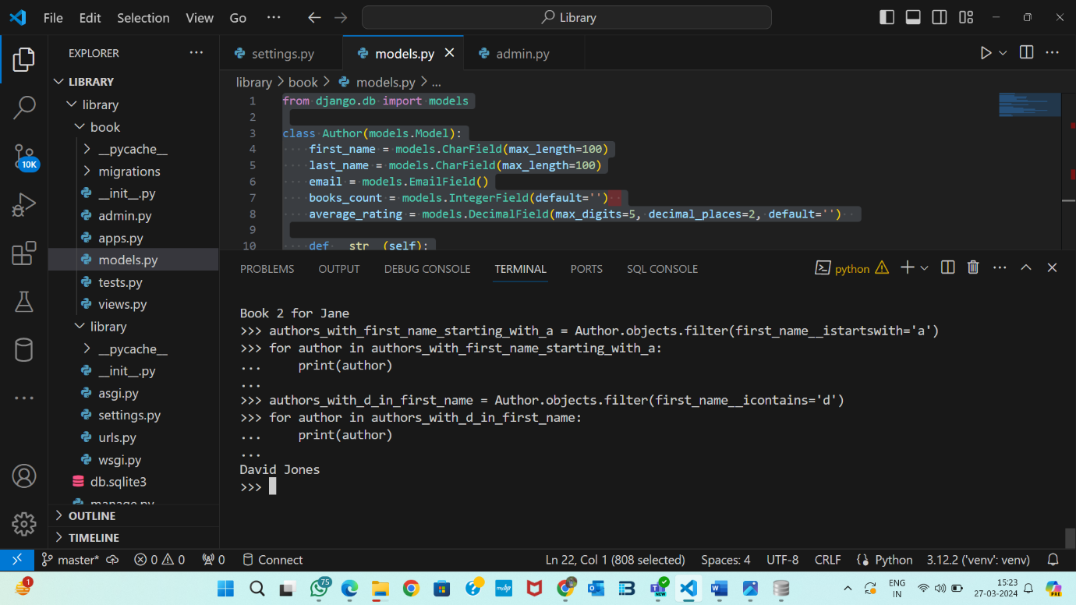

-- delete the books that has book count 0

